NOISE TECHNOLOGIES AND SYSTEMS FOR MINIMIZATION OF ECONOMIC DAMAGE FROM DESTRUCTIVE EARTHQUAKES IN THE COUNTRIES OF SEISMICALLY ACTIVE REGIONS

Telman Aliev, Professor, Academician (Azerbaijan)
Ali Abbasov, Professor, Academician (Azerbaijan)
Tofig Babayev, PhD in Engineering, (Azerbaijan)
Gambar Quluyev, PhD in Engineering, (Azerbaijan)
Fahrad Pashayev, PhD in Engineering, (Azerbaijan)
Abstract
Technologies and systems are offered, in which seismic-acoustic information from deep strata of the earth is received by means of acoustic sensors (hydrophones) installed at heads of suspended oil wells. The information on the state of seismic stability of construction objects is sent from sensors to local systems. Robust noise analysis of both seismic-acoustic data and the data received from all local systems carried out on the system server is used to perform monitoring of the beginning of origin of anomalous seismic processes and change in seismic stability of most vulnerable construction objects. Dealing with the problems of monitoring of seismic stability and identification of change in seismic processes facilitates minimization of damage caused by destructive earthquakes.
Keywords: anomalous seismic processes, correlation functions, identification, matrix, monitoring, noise, robust estimates, seismic stability, seismic-acoustic station, set.
1. Introduction. Numerous scientific research works [1, 4, 10, 14-16] on earthquake forecasting and estimation of technical condition of construction objects have been carried out in the recent years. It is known that currently used seismic systems do not allow forecasting earthquakes with disastrous consequences. There is also a lack of inexpensive and sufficiently reliable systems for control of seismic stability of construction objects. Combination of these two factors during earthquakes leads to numerous accidents with disastrous consequences [1-9].
It is also known that weak earthquakes often occur in the countries located in seismically active areas as a result of originating anomalous seismic processes (ASP). To provide safety of the population after each of such earthquakes, it is efficient to use them to detect the beginning of the latent period of change in seismic stability of residential buildings and strategic objects. The importance of the problem increases manifold, when seismic hazard is complicated by a possibility of landslides [10, 11].
2. Problem statement. In real life, after a certain period of time $T_{0}$ of normal operation of construction objects in seismic regions, period of time $T_{1}$ of their latent transition into the emergency state begins due to different reasons. It is often a result of weak earthquakes, which leads to changes in their seismic stability. Subsequent weak earthquakes, hurricane winds with rain showers cause them to go into time interval of expressed emergency state $T_{2}$.
Despite the difference in duration of $T_{0}$, $T_{1}$, $T_{2}$, monitoring problem in the cases in question comes to providing reliable indication of the beginning of time $T_{1}$ of the period of latent change in the seismic stability of the object or the beginning of the period of origin of anomalous seismic processes [7-13].
Thereby, let us consider the matter in more detail.
Assume that in the normal seismic state in the period of time$T_{0}$, the known classical conditions hold true for noisy centered signals $g\left(iΔt\right)=X\left(iΔt\right)+ε\left(iΔt\right)$ received as the output of corresponding acoustic sensors, for instance, hydrophones, i.e. the equalities [2,3] are true:
$ω_{T_{0}}\left[g\left(iΔt\right)\right]=\frac{1}{\sqrt{2{πD}_{g}}}e^{−\frac{{}^{{(g(iΔt))}^{2}}}{2D_{g}}}$,$D_{ε}≈0$, $D_{g}≈D_{X}$;$R_{\text{gg}}\left(μ\right)≈R_{\text{XX}}\left(μ\right)$;$m_{g}≈m_{X}$;$m_{ε}≈0$; $R_{Xε}\left(μ=0\right)≈0$, $r_{Xε}≈0$, (1)
where $ω_{T_{0}}\left[g\left(iΔt\right)\right]$ is $g\left(iΔt\right)$ signal distribution law; $D_{ε}$, $D_{X}$, $D_{g}$ are the estimates of variance of the noise $ε\left(iΔt\right)$, the useful signal $X\left(iΔt\right)$and the sum signal $g\left(iΔt\right)$ respectively; $R_{\text{XX}}\left(μ\right)$, $R_{\text{gg}}\left(μ\right)$ are the estimates of correlation functions of the useful signal $X\left(iΔt\right)$ and the sum signal $g\left(iΔt\right)$; $m_{ε}$, $m_{X}$, $m_{g}$ are mathematical expectations of the noise $ε\left(iΔt\right)$, the useful signal and the sum signal; $R_{Xε}\left(μ=0\right)$, $r_{Xε}$ are the cross-correlation function and the coefficient of correlation between the useful signal $X\left(iΔt\right)$ and the noise $ε\left(iΔt\right)$.
However, when the latent period $T_{1}$ of origin of anomalous seismic processes or the period of imperceptible change in seismic stability of the object begins, the condition (1) is violated [1-3, 11-13], i.e.:
$ω_{T_{°}}\left[g\left(iΔt\right)\right]≠ω_{T_{1}}\left[g\left(iΔt\right)\right]$, $D_{ε}≠0$, $D_{g}≠D_{X}$,
$R_{\text{gg}}\left(μ\right)≠R_{\text{xx}}\left(μ\right)$,$m_{g}≠m_{x}$, $R_{Xε}\left(μ=0\right)≠0$, $r_{Xε}≠0$. (2)
The period of the normal state $T_{0}$ends and the period $T_{1}$ begins. As a result, due to the violation of the equality (1), statistical estimates of the signal $g\left(iΔt\right)$ are determined with certain inaccuracy. Therefore, timely detection of the initial stage of the above-mentioned processes in control systems is complicate in the period of time $T_{1}$ [14]. Then the period $T_{1}$ ends and the period $T_{2}$ begins, when processes assume a more expressed form. The known monitoring systems mainly register violation of seismic stability of objects in the period of time $T_{2}$. The same happens when an ASP reaches its critical state, when the earthquake occurs, since only this moment is registered by standard seismic stations [13].
The above-mentioned explains the delay in results of monitoring of seismic stability of construction objects and the beginning of ASP. Registration of those processes in the period of time $T_{1}$ therefore requires development of a technology and systems, which would allow one to detect the moment of violation of the equality (1).
To minimize the damage from destructive earthquake, it is therefore necessary to create a city-wide system for both permanent monitoring of the latent period of changes in seismic stability of housing stock and ASP beginning alarm for cities located in seismically active regions. It is also reasonable to create the information technology and system allowing to combine them.
3. Noise technologies for monitoring of the beginning of time $T_{1}$
Our research demonstrated that in the latent period of time$T_{1}$ of ASP origin and at the start of time$T_{1}$of violation of seismic stability of construction objects, estimates of noise variance$D_{ε}$, noise correlation$R_{X\text{εε}}\left(μ=0\right)$, cross-correlation function$R_{Xε}\left(μ=0\right)$, coefficient of correlation $r_{Xε}$between the useful signal $X(iΔt)$and the noise $ε(iΔt)$ change in the first place [7].
In this respect, let us consider one of possible methods of approximate calculation of the indicated estimates. For that end, let us represent the known expression
$D_{g}=R_{\text{gg}}\left(μ=0\right)=\frac{1}{N}\sum_{i=1}^{N}{g\left(iΔt\right)g\left(iΔt\right)}=\frac{1}{N}\sum_{i=1}^{N}{g^{2}\left(iΔt\right)}$ (3)
as follows:
$R_{\text{gg}}\left(μ=0\right)=\frac{1}{N}\sum_{i=1}^{N}{{\left[X\left(iΔt\right)+ε\left(iΔt\right)\right]}^{2}}$. (4)
It is obvious that by opening the brackets we will get the following
$R_{\text{gg}}\left(μ=0\right)=\frac{1}{N}\sum_{i=1}^{N}{X^{2}\left(iΔt\right)}+\frac{1}{N}\sum_{i=1}^{N}{2\left[X\left(iΔt\right)⋅ε\left(iΔt\right)\right]}+\frac{1}{N}\sum_{i=1}^{N}{ε^{2}\left(iΔt\right)}$. (5)
Assuming the following notations
$\frac{1}{N}\sum_{i=1}^{N}{X^{2}\left(iΔt\right)}=R_{\text{XX}}\left(μ=0\right)$, (6)
$\begin{aligned}\left.\frac{1}{N}\sum_{i=1}^{N}{2\left[X\left(iΔt\right)ε\left(iΔt\right)\right]}=2R_{Xε}\left(μ=0\right) | \right\}\end{aligned}$, (7)
we get
$R_{\text{gg}}\left(μ=0\right)=R_{\text{XX}}\left(μ=0\right)+2R_{Xε}\left(μ=0\right)+R_{\text{εε}}\left(μ=0\right)$. (8)
where $R_{X\text{εε}}\left(μ=0\right)$
$2R_{Xε}\left(μ=0\right)+R_{\text{εε}}\left(μ=0\right)=R_{X\text{εε}}\left(μ=0\right)$ (9)
can be called the estimate of noise correlation value.
Thereby, the approximate estimate $R_{X\text{εε}}\left(μ=0\right)$of cross-correlation function between the useful signal and the noise can be determined by means of the following expressions
$2R_{Xε}\left(μ=0\right)≈R_{\text{gg}}\left(μ=0\right)−R_{\text{XX}}\left(μ=0\right)−R_{\text{εε}}\left(μ=0\right)$ . (10)
It is known [7, 8, 11-17] that with the equality (1) being true and with the corresponding sampling interval $Δt$, the following approximate equalities can be regarded as true:
$R_{\text{gg}}\left(μ=1\right)≈R_{\text{XX}}\left(μ=1\right)$, (11)
$R_{\text{gg}}\left(μ=2\right)≈R_{\text{XX}}\left(μ=2\right)$, (12)
$R_{\text{gg}}\left(μ=3\right)≈R_{\text{XX}}\left(μ=3\right)$, (13)
$\begin{aligned}\left.R_{\text{XX}}\left(μ=0\right)=R_{\text{XX}}\left(μ=1\right)+{ΔR}_{\text{XX}}\left(μ=1\right) | \right\}\end{aligned}$, (14)
Taking into account expressions (10)-(14), the following may be written
$R_{\text{XX}}\left(μ=0\right)≈R_{\text{XX}}\left(μ=1\right)+{ΔR}_{\text{XX}}\left(μ=1\right)≈R_{\text{gg}}\left(μ=1\right)+[R_{\text{gg}}\left(μ=2\right)−R_{\text{gg}}\left(μ=3\right)]$. (15)
Expression (8) can therefore be represented as follows
$R_{\text{gg}}\left(μ=0\right)=R_{\text{gg}}\left(μ=1\right)+[R_{\text{gg}}\left(μ=2\right)−R_{\text{gg}}\left(μ=3\right)]+2R_{Xε}\left(μ=0\right)+R_{\text{εε}}\left(μ=0\right)$, (16)
whence the expression (10) can be reduced to the following form
$$2R_{Xε}\left(μ=0\right)=\left[R_{\text{gg}}\left(μ=0\right)−\left[R_{\text{gg}}\left(μ=1\right)+\left(R_{\text{gg}}\left(μ=2\right)−R_{\text{gg}}\left(μ=3\right)\right)\right]−R_{\text{εε}}\left(μ=0\right)\right]$$
$\begin{aligned}R_{Xε}\left(μ=0\right)≈\frac{1}{2}\left[R_{\text{gg}}\left(μ=0\right)−\left[R_{\text{gg}}\left(μ=1\right)+\left(R_{\text{gg}}\left(μ=2\right)−R_{\text{gg}}\left(μ=3\right)\right)\right]−R_{\text{εε}}\left(μ=0\right)\right]≈≈\frac{1}{2}\sum{\left[g\left(iΔt\right)g\left(iΔt\right)−\left[g\left(iΔt\right)g\left(i+1\right)Δt+g\left(iΔt\right)g\left(i+2\right)Δt−g\left(iΔt\right)g\left(i+3\right)Δt−D_{\text{εε}}\right]\right]}\end{aligned}$, (17)
and the expression (9) can be represented as follows:
$\begin{aligned}R_{X\text{εε}}\left(μ=0\right)≈R_{\text{gg}}\left(μ=0\right)−\left[R_{\text{gg}}\left(μ=1\right)+R_{\text{gg}}\left(μ=2\right)−R_{\text{gg}}\left(μ=3\right)\right]+R_{\text{εε}}\left(μ=0\right)−D_{ε}= \\ R_{\text{gg}}\left(μ=0\right)−\left[R_{\text{gg}}\left(μ=1\right)+R_{\text{gg}}\left(μ=2\right)−R_{\text{gg}}\left(μ=3\right)\right]\end{aligned}$, (18)
This expression can be used to calculate the estimate $R_{X\text{εε}}\left(0\right)$, i.e. the value of noise correlation. The experiments showed that the values of estimates $R_{Xε}\left(0\right)$, $R_{X\text{εε}}\left(0\right)$ change sharply at the start of time $T_{1}$, and they become carriers of diagnostic information both on change in seismic stability and on the beginning of ASP origin.
The experiments also showed that the estimate of noise variance $D_{ε}$can be used as a reliable indicator in the monitoring of seismic stability of high-rise buildings, which is due to the fact that estimates of characteristics of the noise $ε\left(iΔt\right)$ at the start of time span $T_{1}$ change sharply both in the presence and in the absence of correlation between $X\left(iΔt\right)$ and $ε\left(iΔt\right)$. When $R_{Xε}\left(0\right)≈0$, the estimate of noise variance $D_{ε}$can be determined from the formula [2, 3]:
$D_{ε}=\frac{1}{N}\sum_{i=1}^{N}{\left[g^{2}\left(iΔt\right)+g\left(iΔt\right)g\left(i+2\right)Δt−2g\left(iΔt\right)g\left(i+1\right)Δt\right]}$ (19)
It is obvious that, knowing the estimate $D_{ε}$, it is also possible to determine the estimate of useful signal variance $D_{x}$from the expression
$D_{x}=D_{g}−D_{ε}$ (20)
It is only possible to determine the estimate of noise variance $D_{ε}$cross-correlation function $R_{Xε}\left(μ=0\right)$ from the expressions (17), (19) when there is no correlation between $X\left(iΔt\right)$ and $ε\left(iΔt\right)$. To calculate them in the presence of correlation, a technology for determination of the estimate of relay cross-correlation function $R_{{}_{Xε}}^{}\left(μ=0\right)$ must be developed. It is also reasonable to use the estimate of relay cross-correlation function $R_{{}_{Xε}}^{}\left(μ=0\right)$ as a carrier of diagnostic information to increase the reliability and adequacy of monitoring results of the start of time $T_{1}$. Taking the above-mentioned into account, let us consider the matter in more detail. For that end, let us first assume the following notations:
$\text{sgn} g\left(iΔt\right)=\text{sgn} x\left(iΔt\right)=\begin{aligned}\left\{1 \text{at} g\left(iΔt\right)>0 | \right.\left\{0 \text{at} g\left(iΔt\right)=0 | \right.\end{aligned}$ (21)
and
$\left.\begin{matrix}\frac{1}{N}\sum_{i=1}^{N}{\text{sgn} g\left(iΔt\right)}⋅ε\left(i+μ\right)Δt≠0 & \text{at} μ=0 \\ \frac{1}{N}\sum_{i=1}^{N}{\text{sgn} g\left(iΔt\right)}⋅ε\left(i+μ\right)Δt=0 & \text{at} μ≠0 \\ \frac{1}{N}\sum_{i=1}^{N}{ε\left(iΔt\right)}⋅ε\left(iΔt\right)≠0 & \text{at} μ=0 \\ \frac{1}{N}\sum_{i=1}^{N}{ε\left(iΔt\right)}⋅ε\left(i+μ\right)=0 & \text{at} μ≠0\end{matrix}\right\}$. (22)
The formula for determination of estimates of relay correlation function $R_{\text{gg}}^{}\left(μ=0\right)$ in the presence of correlation between $X\left(iΔt\right)$ and $ε\left(iΔt\right)$ here can be represented as follows:
$R_{\text{gg}}^{}\left(μ=0\right)=\frac{1}{N}\sum_{i=1}^{N}{\text{sgn} g\left(iΔt\right)g\left(iΔt\right)}=\frac{1}{N}\sum_{i=1}^{N}{\text{sgn} g\left(iΔt\right)}⋅\left[X\left(iΔt\right)+ε\left(iΔt\right)\right]=$
$=\frac{1}{N}\sum{\text{sgn} X\left(iΔt\right)X\left(iΔt\right)}+\frac{1}{N}\sum_{1}{\text{sgn} X\left(iΔt\right)}ε\left(iΔt\right)=R_{\text{XX}}^{}\left(μ=0\right)+R_{Xε}^{}\left(μ=0\right)$. (23)
In the presence of correlation between $X\left(iΔt\right)$ and $ε\left(iΔt\right)$, the following expressions can be regarded as true:
$\begin{aligned}\left.{ΔR}_{\text{gg}}^{}\left(μ=0\right)−{ΔR}^{{}_{\text{gg}}}\left(μ=1\right)≠{ΔR}^{{}_{\text{gg}}}\left(μ=1\right)−{ΔR}^{{}_{\text{gg}}}\left(μ=2\right) | \right\}\left.{ΔR}^{{}_{\text{gg}}}\left(μ=1\right)−{ΔR}^{{}_{\text{gg}}}\left(μ=2\right)≈{ΔR}^{{}_{\text{gg}}}\left(μ=2\right)−{ΔR}^{{}_{\text{gg}}}\left(μ=3\right)≈{ΔR}^{{}_{\text{gg}}}\left(μ=3\right)−{ΔR}^{{}_{\text{gg}}}\left(μ=4\right)≈0 | \right\}\end{aligned}$ (24)
It follows from the equality (21)-(24) that the estimate of relay cross-correlation function $R_{Xε}^{}\left(μ=0\right)$ can be determined from the formula:
${ΔR}_{\text{gg}}^{}\left(μ=0\right)≈R_{\text{XX}}^{}\left(μ=0\right)+R_{Xε}^{}\left(μ=0\right)$, (25)
where
$R_{Xε}^{}\left(0\right)≈{ΔR}^{{}_{\text{gg}}}\left(μ=0\right)−R^{{}_{\text{XX}}}\left(μ=0\right)$ (26)
Therefore, to calculate $R_{Xε}^{}\left(μ=0\right)$ by means of the expression (26), $R^{{}_{\text{XX}}}\left(μ=0\right)$must be calculated. The equalities (24) imply that the estimate $R_{\text{XX}}^{}\left(μ=0\right)$ can be calculated by means of the following expression
$$R_{\text{XX}}^{}\left(μ=0\right)≈R_{\text{XX}}^{}\left(μ=1\right)+{ΔR}_{\text{XX}}^{}\left(μ=1\right)≈R_{\text{gg}}^{}\left(μ=1\right)+{ΔR}_{\text{gg}}^{}\left(μ=1\right)≈R_{\text{gg}}^{}\left(μ=1\right)+$$
$+\left[R_{\text{gg}}^{}\left(μ=1\right)−R_{\text{gg}}^{}\left(μ=2\right)\right]=2R_{\text{gg}}^{}\left(μ=1\right)−R_{\text{gg}}^{}\left(μ=2\right)$. (27)
Thus, the expression (26) can represented as follows:
$R_{Xε}^{}\left(μ=0\right)=R_{\text{gg}}^{}\left(μ=0\right)−\left[2R_{\text{gg}}^{}\left(μ=1\right)−R_{\text{gg}}^{}\left(μ=2\right)\right]=R_{\text{gg}}^{}\left(μ=0\right)−2R_{\text{gg}}^{}\left(μ=1\right)+R_{\text{gg}}^{}\left(μ=2\right)$. (28)
The expression for calculation of the estimate of relay cross-correlation function $R_{Xε}^{}\left(μ=0\right)$ between the useful seismic acoustic signal$X\left(iΔt\right)$ and its noise$ε\left(iΔt\right)$ can therefore be written as follows:
$R_{Xε}^{}\left(μ=0\right)≈\frac{1}{N}\sum_{i=1}^{N}{[\text{sgn} g\left(iΔt\right)g\left(iΔt\right)}−2\text{sgn} g\left(iΔt\right)g\left(\left(i+1\right)Δt\right)+\text{sgn} g\left(iΔt\right)g\left(\left(i+2\right)Δt\right)]$ (29)
As was indicated above, it is possible to calculate the estimates of $D_{ε}$ when $R_{Xε}\left(μ=0\right)≈0$, using the expression (19). It is, however, impossible to use this expression in the presence of correlation between $X\left(iΔt\right)$ and $ε\left(iΔt\right)$. Accordingly, let us consider the possibility of determining $D_{ε}$when $R_{Xε}\left(μ=0\right)≠0$, using the estimates $R_{X\text{εε}}\left(μ=0\right)$, $R_{Xε}^{}\left(μ=0\right)$, ${ΔR}_{\text{gg}}\left(μ=0\right)$ and ${ΔR}_{\text{gg}}^{}\left(μ=0\right)$. in more detail.
Taking into account the conditions (24) and equalities (25) – (29), the following can be written:
$\begin{aligned}\left.R_{Xε}^{}\left(μ=0\right)+{ΔR}_{\text{XX}}^{}\left(μ=0\right)≈{ΔR}_{\text{gg}}^{}\left(μ=0\right) | \right\}\left.R_{Xε}\left(μ=0\right)+R_{\text{εε}}\left(μ=0\right)+{ΔR}_{\text{XX}}\left(μ=0\right)≈{ΔR}_{\text{gg}}\left(μ=0\right) | \right\}\end{aligned}$ (30).
The correlation between the estimates$R_{Xε}^{}\left(μ=0\right)$; $R_{\text{XX}}^{}\left(μ=1\right)$ and $R_{Xε}\left(μ=0\right)$; ${ΔR}_{\text{XX}}\left(μ=1\right)$, as well as the correlation between the estimates$R_{Xε}^{}\left(μ=0\right)$; ${ΔR}_{{}_{\text{gg}}}^{}\left(μ=1\right)$ and $R_{Xε}\left(μ=0\right)$; ${ΔR}_{\text{gg}}\left(μ=1\right)$ allow one to assume that the following approximate equalities are true:
$\begin{aligned}\left.\frac{R_{Xε}^{}\left(μ=0\right)}{{ΔR}_{\text{XX}}^{}\left(μ=1\right)}≈\frac{R_{Xε}\left(μ=0\right)}{{ΔR}_{\text{XX}}\left(μ=1\right)} | \right\}\end{aligned}$. (31)
In this case, we obtain the following equality:
$R_{Xε}\left(μ=0\right){ΔR}_{\text{gg}}^{}\left(μ=1\right)≈R_{Xε}^{}\left(μ=0\right){ΔR}_{\text{gg}}\left(μ=1\right)$ (32)
Thus, in the presence of correlation between the useful signal$X\left(iΔt\right)$ and the noise$ε\left(iΔt\right)$, the estimate $R_{Xε}\left(0\right)$ can be determined from the formula:
$R_{Xε}\left(μ=0\right)≈\frac{R_{{}_{Xε}}^{}\left(μ=0\right){ΔR}_{\text{gg}}\left(μ=1\right)}{{ΔR}_{{}_{\text{gg}}}^{}\left(μ=1\right)}$ (33)
It is clear that after the estimate$R_{Xε}\left(0\right)$ is determined, the estimate of noise variance$D_{ε}$ can be determined both by means of the expression:
$D_{ε}=R_{\text{εε}}\left(μ=0\right)≈{ΔR}_{\text{gg}}\left(μ=0\right)−{ΔR}_{\text{gg}}\left(μ=1\right)−R_{Xε}\left(μ=0\right)$ (34)
and by means of the expression:
$D_{ε}=R_{X\text{εε}}\left(μ=0\right)−R_{Xε}\left(μ=0\right)$ (35)
where$R_{X\text{εε}}$ is determined from the formula (18).
4. Robust correlation indicators of the beginning of ASP origin
Let us consider the possibility of registration of the beginning of the period $T_{1}$ of change in seismic stability of construction objects from estimates of auto- and cross-correlation functions $R_{\text{gg}}\left(μ\right)$ and $R_{g_{j}g_{v}}\left(μ\right)$. Analysis of the peculiarity of calculation of those estimates demonstrates that their inaccuracy depends on the change in the spectrum of the noise $ε\left(iΔt\right)$, which is why they do not meet the conditions of robustness [2,3]. However, with increase of time shift $μ⋅Δt$ between $g\left(iΔt\right)$ and $g\left(\left(i+μ\right)Δt\right)$, as well as between $g_{j}\left(iΔt\right)$ and $g_{ν}\left(\left(i+μ\right)Δt\right)$, there comes a moment when obtained estimates turn out to be equal to zero. If we denote that time shift by $μ^{'}⋅Δt$, the following obvious equalities will take place:
$\begin{aligned}\left.R_{\text{gg}}\left(μ^{'}\right)=\frac{1}{N}\sum_{i=1}^{N}{g\left(iΔt\right)g\left(\left(i+μ^{'}\right)Δt\right)}≈0 | \right\}\end{aligned}$, (36)
With the time shift $μ^{'}⋅Δt$, inaccuracy of estimates $R_{\text{gg}}\left(μ\right)$ forms from the sum of errors of products $g\left(iΔt\right)g\left(\left(i+μ^{'}\right)Δt\right)$ with positive and negative signs in the quantity $N^{+}$, $N^{−}$respectively. Only in that case, the equality $N^{+}=N^{−}$takes place. Owing to that, the condition of robustness holds true, positive and negative errors of products practically compensating one another. The following equality can therefore be regarded as true:
$R_{\text{gg}}^{+}\left(μ=μ^{'}\right)≈\frac{1}{N}\sum_{i=1}^{N^{+}}{g\left(iΔt\right)g\left(\left(i+μ^{'}\right)Δt\right)}=\frac{1}{N}\sum_{i=1}^{N^{−}}{g\left(iΔt\right)g\left(\left(i+μ^{'}\right)Δt\right)}R_{\text{gg}}^{−}\left(μ=μ^{'}\right)$. (37)
It is clear that estimates of cross-correlation functions, i.e. $R_{g_{j}g_{ν}}\left(μ^{'}\right)$, will also have robustness property and the following can also be written for them:
$R_{g_{j}g_{ν}}^{+}\left(μ=μ^{'}\right)=R_{g_{j}g_{ν}}^{−}\left(μ=μ^{'}\right)$. (38)
With the reference to the above-mentioned, the equalities (32), (33) will be violated at the moment of start of the period $T_{1}$ of ASP, i.e.
$R_{\text{gg}}^{+}\left(μ=μ^{'}\right)≠R_{\text{gg}}^{−}\left(μ=μ^{'}\right)$, $R_{g_{j}g_{v}}^{+}\left(μ=μ^{'}\right)R_{g_{j}g_{v}}^{−}\left(μ=μ^{'}\right)$.
Estimates obtained in the time shift $μ=μ^{'}Δt$ will therefore be different from zero at the start of ASP origin, i.e.
$R_{\text{gg}}\left(μ^{'}\right)=R_{\text{gg}}^{+}\left(μ^{'}\right)−R_{\text{gg}}^{−}\left(μ^{'}\right)≠0$, (39)
$R_{g_{j}g_{ν}}\left(μ^{'}\right)=R_{g_{j}g_{ν}}^{+}\left(μ^{'}\right)−R_{g_{j}g_{ν}}^{−}\left(μ^{'}\right)0$. (40)
Thus, in virtue of the equalities (37), (38), the influence of the noise on the obtained estimates in the period of time $T_{0}$ is compensated, thereby ensuring their robustness. Estimates $R_{\text{gg}}\left(μ^{'}\right)$ will be different from zero due to violation of the condition (1) only in the beginning of change in seismic stability and at ASP origin, i.e. at the start of the time span $T_{1}$. Estimates $R_{\text{gg}}\left(μ\right)$, $R_{g_{j}g_{ν}}\left(μ^{'}\right)$ can therefore be regarded as reliable indicators, calculation of which can be easily parallelized with determination of estimates $R_{X\text{εε}}\left(μ=0\right)$, $R_{Xε}\left(μ=0\right)$, $D_{ε}$.
Accordingly, in the process of the system operation, estimates of signals $g_{1}\left(iΔt\right)$ calculated from the expressions (36) are used to form estimates of robust correlation indicators$R_{g_{1}g_{1}}\left(μ^{'}\right)$, which are equal to zero in the original state of seismic stability$T_{0}$. They will be different from zero when this state changes, i.e. at the start of $T_{1}$.
5. Robust technology for identification of technical condition and seismic stability of construction objects
To solve the problem of identification of seismic stability, let us first of all consider the possibility of applying methods of theory of random processes for that end. It is known that that [17] the state of seismic stability of construction object in the period of time $T_{1}$ in the general case is described with matrix equalities of the following type
${\vec{R}}_{\text{XY}}\left(μ\right)$=${\vec{R}}_{\text{XX}}\left(μ\right)$$\vec{W}\left(μ\right)$, $μ=\begin{matrix}0, & Δt, & 2Δt, & …, & \left(N−1\right)Δt\end{matrix}$, (41)
where
${\vec{R}}_{\text{XX}}\left(μ\right)$=$\left\|\begin{matrix}R_{\text{XX}}\left(0\right) & R_{\text{XX}}\left(Δt\right) & … & R_{\text{XX}}\left[\left(N−1\right)Δt\right] \\ R_{\text{XX}}\left(Δt\right) & R_{\text{XX}}\left(0\right) & … & R_{\text{XX}}\left[\left(N−2\right)Δt\right] \\ … & … & … & … \\ R_{\text{XX}}\left[\left(N−1\right)Δt\right] & R_{\text{XX}}\left[\left(N−2\right)Δt\right] & … & R_{\text{XX}}\left(0\right)\end{matrix}\right\|$, (42)

${\vec{R}}_{\text{XY}}\left(μ\right)$=${\left[\begin{matrix}R_{\text{XY}}\left(0\right) & R_{\text{XY}}\left(Δt\right) & … & R_{\text{XY}}\left[\left(N−1\right)Δt\right]\end{matrix}\right]}^{T}$, (43)
$\vec{W}\left(μ\right)$=${\left[\begin{matrix}W\left(0\right) & W\left(Δt\right) & … & W\left(\left(N−1\right)Δt\right)\end{matrix}\right]}^{T}$, (44)
${\vec{R}}_{\text{XX}}\left(μ\right)$ is the square symmetric matrix of auto-correlation functions with dimension $N×N$ of centered input signal $X\left(t\right)$; ${\vec{R}}_{\text{XY}}\left(μ\right)$ is the column vector of cross-correlation functions between the input $X\left(t\right)$ and output $Y\left(t\right)$; $m_{X}$, $m_{Y}$are mathematical expectations of $X\left(t\right)$, $Y\left(t\right)$ respectively; $\vec{W}\left(μ\right)$ is the column vector of impulsive admittance functions.
Matrices (42), (43), equations (41) are formed from the estimates of useful signals $X\left(t\right)$ and $Y\left(t\right)$. However, in the process of solving of real tasks, these matrices are formed from estimates of technological parameters, which represent noisy signals $g_{1}\left(iΔt\right), g_{2}\left(iΔt\right), …, g_{m}\left(iΔt\right)$. Thus, they contain errors from noises $ε_{1}\left(iΔt\right), ε_{2}\left(iΔt\right), …, ε_{m}\left(iΔt\right)$. With estimates of noise variances and cross-correlation function between the useful signal and the noise changing, their errors change as well. To ensure adequate results of identification of technical condition and seismic stability of objects by means of matrix equation (41), it is therefore first of all necessary to ensure robustness of estimates of elements of those matrices [17]. There is a good reason to use the technology of calculation of robust estimates of auto- and cross-correlation functions from the following expressions:
$R_{\text{gg}}^{R}(μ)=\frac{1}{N}\sum_{i=1}^{N}{g(iΔt)g((i+μ)Δt)−[N^{+}(μ)−N^{−}(μ)]\left\langle Δλ(μ=0)\right\rangle }$; (45)
$R_{gη}^{R}(μ)=\frac{1}{N}\sum_{i=1}^{N}{g(iΔt)η((i+μ)Δt)−[N^{+}(μ)−N^{−}(μ)]\left\langle Δλ(μ=0)\right\rangle }$. (46)
where
$\begin{aligned}\left.\left|R_{\text{gg}}(μ=1)−R_{{}_{\text{gg}}}^{}(μ=1)\right|=λ(μ=1) | \right\}\end{aligned}$, (47)
$\left\langle Δλ(μ=1)\right\rangle =[1/N^{−}(μ=1)]λ(μ=1)$. (48)

$R_{\text{gg}}\left(μ=1\right)$, $R_{{}_{\text{gg}}}^{}\left(μ=1\right)$, $R_{gη}\left(μ=1\right)$, $R_{{}_{gη}}^{}\left(μ=1\right)$ are the estimates of auto- and cross-correlation functions of centered and uncentered signals $g\left(iΔt\right) , η\left(iΔt\right)$ respectively.
$N^{+}\left(μ\right)$, $N^{−}\left(μ\right)$ are the quantities of products $g\left(iΔt\right) g\left(i+μ\right)Δt$ or $g\left(iΔt\right) η\left(iΔt\right)$ with positive and negative signs respectively.
It is obvious that when elements of matrices (42), (43) are formed from robust estimates from expressions (45), (46), matrix equation (42) can be represented as follows.
$\vec{R_{gη}^{R}}\left(μ\right)≈\vec{R_{\text{gg}}^{R}}\left(μ\right)\vec{W}\left(μ\right), μ=0, Δt, 2Δt, …, \left(N−1\right)Δt$ (49)
Elements of matrices $\vec{R_{\text{gg}}^{R}}\left(μ\right)$, $\vec{R_{gη}^{R}}\left(μ\right)$ here are robust estimates of noisy signals, i.e.
$\vec{R_{{}_{\text{gg}}}^{R}}\left(μ\right)=\left\|\begin{matrix}R_{\text{gg}}^{R}\left(0\right) & R_{\text{gg}}^{R}\left(Δt\right) & … & R_{\text{gg}}^{R}\left[\left(N−1\right)Δt\right] \\ R_{\text{gg}}^{R}\left(Δt\right) & R_{\text{gg}}^{R}\left(0\right) & … & R_{\text{gg}}^{R}\left[\left(N−2\right)Δt\right] \\ … & … & … & … \\ R_{\text{gg}}^{R}\left[\left(N−1\right)Δt\right] & R_{\text{gg}}^{R}\left[\left(N−2\right)Δt\right] & … & R_{\text{gg}}^{R}\left(0\right)\end{matrix}\right\|$ (50)

$\vec{R_{{}_{gη}}^{R}}\left(μ\right)={\left[R_{gη}^{R}\left(0\right) R_{gη}^{R}\left(Δt\right)…R_{gη}^{R}\left[\left(N−1\right)Δt\right]\right]}^{T}$ (51)
According to [18], in calculation of correlation function from expressions (45), (46), errors from noises are virtually excluded from robust estimates of elements of matrices (50), (51). The following equality can thereby be regarded as true
$\begin{aligned}\left.\vec{W}\left(μ\right)={\left[\begin{matrix}W^{'}\left(0\right) & W^{'}\left(Δt\right) & … & W\left[\left(N−1\right)Δt\right]\end{matrix}\right]}^{T} | \right\}\end{aligned}$ (52)
Thus, it can be assumed that adequacy of the results obtained in the process of identification of seismic stability by means of matrix equation (49) will be satisfactory.
At the same time, sensors are also often used for real objects, in which signals at the output are various physical quantities. For the cases when sensors are installed at construction objects for measuring of various physical quantities (vibration, pressure, motion etc.), estimates of correlation functions of signals $g_{1}\left(iΔt\right), g_{2}\left(iΔt\right), …, g_{n}\left(iΔt\right)$ must be reduced to dimensionless quantities.
This is realized by using the procedure of normalization of matrix elements (42), (43), (50), (51) [17, 18]. Only values of auto-correlation function here prove to be accurate when time shift is equal to zero $μ$=0. In all other cases, i.e. normalization for estimates of auto-correlation functions at time shifts $μ≠$0 and for estimates of cross-correlation functions at all time shifts $μ$, unfortunately, leads to emergence of additional errors from the noise. In the presence of correlation between the useful signal and the noise, normalization of the value of estimation error results in even greater inadequacy of solution of the above-mentioned problems. In this respect, a technology is required that ensures elimination of estimation error caused by normalization.
6. Intelligent distributed system of noise monitoring of seismic stability of construction objects
As Fig. 1 shows, the system under consideration includes the monitoring center (MC), seismic-acoustic station for robust noise monitoring of anomalous seismic processes (RNM ASP) and local devices for noise monitoring of seismic stability (LDNS) $L_{\text{11}},L_{\text{12}},\text{.}\text{.}\text{.},L_{1n},\text{.}\text{.}\text{.},L_{\text{nm}}$ installed at all controlled construction objects. In Fig. 1, the totality of LDNS with transmitting antennas is the distributed system for noise monitoring of seismic stability of construction objects.
Creation of the system implies that every socially significant and strategic object is equipped with LDNS built on the basis of controllers and corresponding sensors installed in most vulnerable structures of the object.
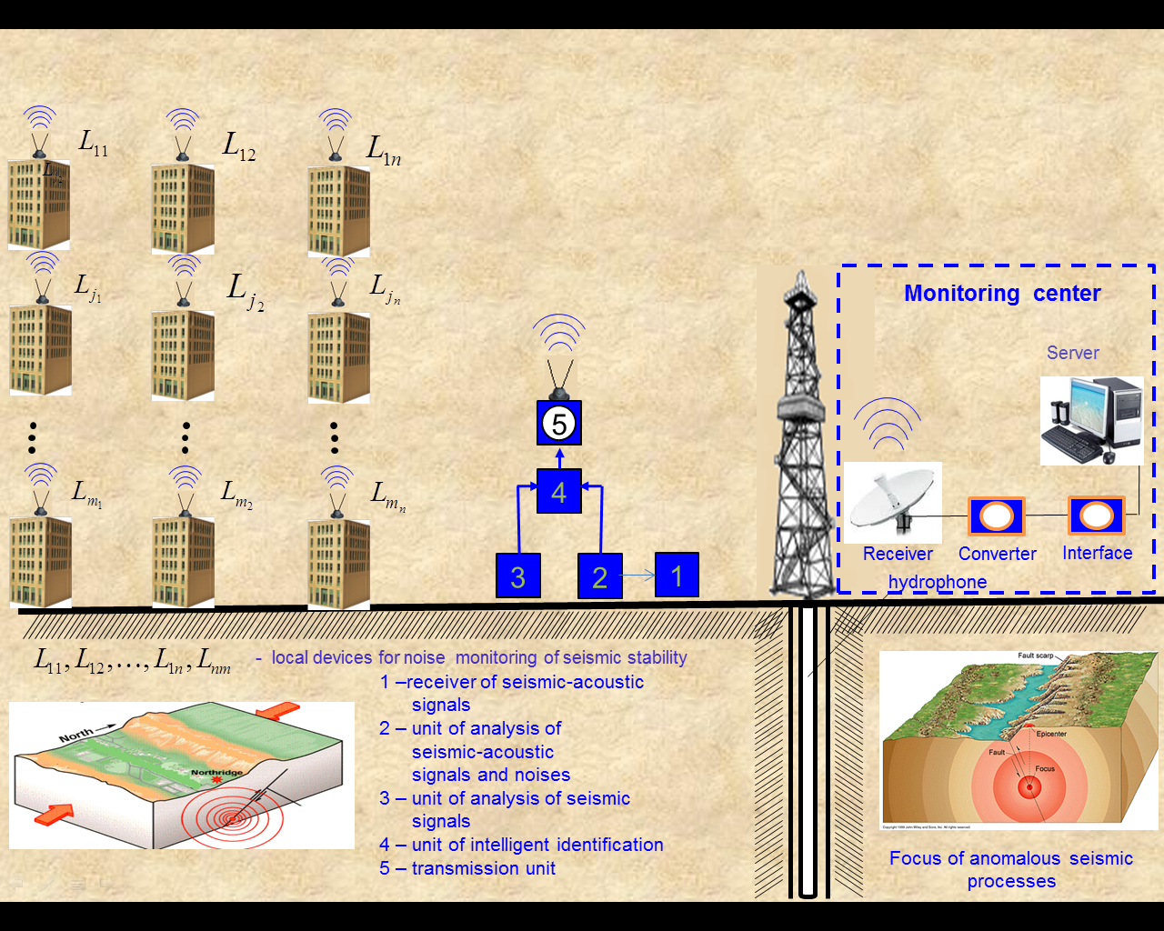
Fig. 1. Intelligent distributed system of noise monitoring of seismic stability of construction objects
LDNS operate independently. In the process of operation of the monitoring system, characteristics of signals $g_{1}\left(iΔt\right), g_{2}\left(iΔt\right), \text{.}\text{.}\text{.}, g_{m}\left(iΔt\right)$ received from the corresponding sensors are determined from expressions (18-19), (29) and used to form the combination of estimates $R_{X\text{εε}}\left(0\right), R_{Xε}\left(0\right), R_{{}_{Xε}}^{}\left(0\right),D_{ε}$, which will be equal to zero in the original state of normal seismic stability. When the original state of seismic stability changes in the beginning of period $T_{1}$, they will be different from zero. Similarly, they will be different from zero at the moment of ASP origin in the beginning of period $T_{1}$ as well. Thus, in the period of time $T_{0}$, sets of informative attributes used as convenient and reliable indicators are formed from the above-mentioned estimates in the LDNS of each object.
$W_{Xε}=\begin{aligned}\left\{\begin{matrix}R_{X_{1}ε_{1}ε_{1}}\left(0\right) & R_{X_{2}ε_{2}ε_{2}}\left(0\right) & … & R_{X_{j}ε_{j}ε_{j}}\left(0\right) & … & R_{X_{m}ε_{m3}ε_{m}}\left(0\right) \\ R_{X_{1}ε_{1}}(0) & R_{X_{2}ε_{2}}(0) & … & R_{X_{j}ε_{j}}(0) & … & R_{X_{m}ε_{m}}(0) \\ R_{{}_{X_{1}ε_{{}_{1}}}}^{}\left(0\right) & R_{{}_{X_{2}ε_{{}_{2}}}}^{}\left(0\right) & … & R_{{}_{X_{j}ε_{{}_{j}}}}^{}\left(0\right) & … & R_{{}_{X_{m}ε_{{}_{m}}}}^{}\left(0\right)\end{matrix} | \right\}\end{aligned}\left\{\right\}$. (53)
If seismic stability of the object changes, certain elements of those sets will be different from zero. Such a moment will be registered and sent via radio channel of corresponding LDNS to the server of the monitoring center.
Besides, to increase accuracy of monitoring results from (31), (32), it is also reasonable to form sets of indicators from robust estimates of auto- and cross-correlation functions of signal $g_{1}\left(iΔt\right), g_{2}\left(iΔt\right),…, g_{m}\left(iΔt\right)$ in the following form:

$W_{g_{i}g_{j}}=\begin{aligned}\left\{\begin{matrix}R_{{}_{g_{1}g_{1}}}^{R}\left(μ^{'}\right) & R_{{}_{g_{1}g_{2}}}^{R}\left(μ^{'}\right) & R_{{}_{g_{1}g_{3}}}^{R}\left(μ^{'}\right) & R_{{}_{g_{1}g_{4}}}^{R}\left(μ^{'}\right),…,R_{{}_{g_{1}g_{j}}}^{R}\left(μ^{'}\right),…R_{{}_{g_{1}g_{m}}}^{R}\left(μ^{'}\right) \\ R_{{}_{g_{2}g_{2}}}^{R}\left(μ^{'}\right) & R_{{}_{g_{2}g_{1}}}^{R}\left(μ^{'}\right) & R_{{}_{g_{2}g_{3}}}^{R}\left(μ^{'}\right) & R_{{}_{g_{2}g_{4}}}^{R}\left(μ^{'}\right),…,R_{{}_{g_{2}g_{j}}}^{R}\left(μ^{'}\right)…R_{{}_{g_{2}g_{m}}}^{R}\left(μ^{'}\right) \\ R_{{}_{g_{3}g_{3}}}^{R}\left(μ^{'}\right) & R_{{}_{g_{3}g_{1}}}^{R}\left(μ^{'}\right) & R_{{}_{g_{3}g_{2}}}^{R}\left(μ^{'}\right) & R_{{}_{g_{3}g_{4}}}^{R}\left(μ^{'}\right),…,R_{{}_{g_{3}g_{j}}}^{R}\left(μ^{'}\right),…,R_{{}_{g_{3}g_{m}}}^{R}\left(μ^{'}\right) \\ ⋮ & ⋮ & ⋮ & ⋮\end{matrix} | \right\}\left\{\begin{matrix}R_{{}_{g_{j}g_{j}}}^{R}\left(μ^{'}\right) & R_{{}_{g_{j}g_{1}}}^{R}\left(μ^{'}\right) & R_{{}_{g_{j}g_{2}}}^{R}\left(μ^{'}\right) & R_{{}_{g_{j}g_{3}}}^{R}\left(μ^{'}\right),…,R_{{}_{g_{j}g_{j+1}}}^{R}\left(μ^{'}\right)\end{matrix},…,R_{{}_{g_{j}g_{m}}}^{R}\left(μ^{'}\right) | \right\}\left\{ ⋮ ⋮ ⋮ ⋮ | \right\}\end{aligned}\left\{\right\}$ . (54)
where $μ^{'}$ is time shifts between $g\left(iΔt\right)$ and $g\left(i+μ^{'}\right)Δt$, when estimates $R_{{}_{{}_{g_{{}_{i}}g_{{}_{j}}}}}^{R}\left(μ^{'}\right)$ in the period of time $T_{0}$ will be equal to zero.
At that moment of violation of seismic stability, even one element of those sets being different from zero is perceived as the beginning of time $T_{1}$ in LDNS of each object. In that case, the number of the set, column and line of the nonzero informative attribute can be used to identify the location and nature of deformation in the object. At the same time, LDNS also alarms the server of the monitoring center.
Furthermore, in each cycle, readings of signals $g_{1}\left(iΔt\right), g_{2}\left(iΔt\right), …, g_{m}\left(iΔt\right)$ in each LDNS of each object are used to form files, which are transmitted to the modem of the server of the monitoring center via modems and wireless communication together with sets (53), (54). In the operation process, in addition to sets (53), (54), robust normalized correlation matrices form during the period of time $T_{0}$at the server for each object are formed. It is also possible to form a set consisting of position-binary and spectral indicators on the server.
The technologies of their formation are given in detail in [17,18]. Thus, pattern sets and correlation matrices form in the training process, which carry information on the state of original seismic stability of all controlled objects.
In the operation process, current readings of signals $g_{1}\left(iΔt\right),g_{2}\left(iΔt\right),\text{.}\text{.}\text{.},g_{m}\left(iΔt\right)$ in each cycle of monitoring mode are used to form current estimates of elements of the mentioned sets and matrices and compare them with the estimates of corresponding pattern sets and matrices set in the training process. If their difference does not exceed the permissible minimum range, seismic stability and technical condition of the object are regarded as unchanged. Otherwise, the signal forms from the result obtained on the server, which shows the beginning of change in seismic stability of the object. In repetitive cycles, if current estimates differ from patterns again, the decision is made on the server to refer the object to the group that requires involving of mobile control and diagnostic systems to perform the final analysis and decision-making.
If deviation from the normal state of seismic stability is detected simultaneously at closely-spaced groups of objects, a landslide alarm is formed on the server.
The system also provides for safety threat control. For instance, in case of elevator failure, short circuit in power supply, etc. in monitoring object, a corresponding alarm is formed on the server with specification off the nature of failure and object number.
7. Results of experiments of seismic-acoustic monitoring (ASP) at the RNM ASP station at Qum Island in the Caspian Sea
An experimental version of seismic-acoustic station was installed at the head of 3,500 m deep suspended oil well No 5 on 01.07.2010. The well is filled with water and, for this reason, a BC 312 type hydrophone is used as a sensor. The structure of RNM ASP station is given in Fig. 3. Fig. 4 shows the external appearance of RNM ASP station. A building was constructed afterwards to protect the station from the sun, wind and other external factors.
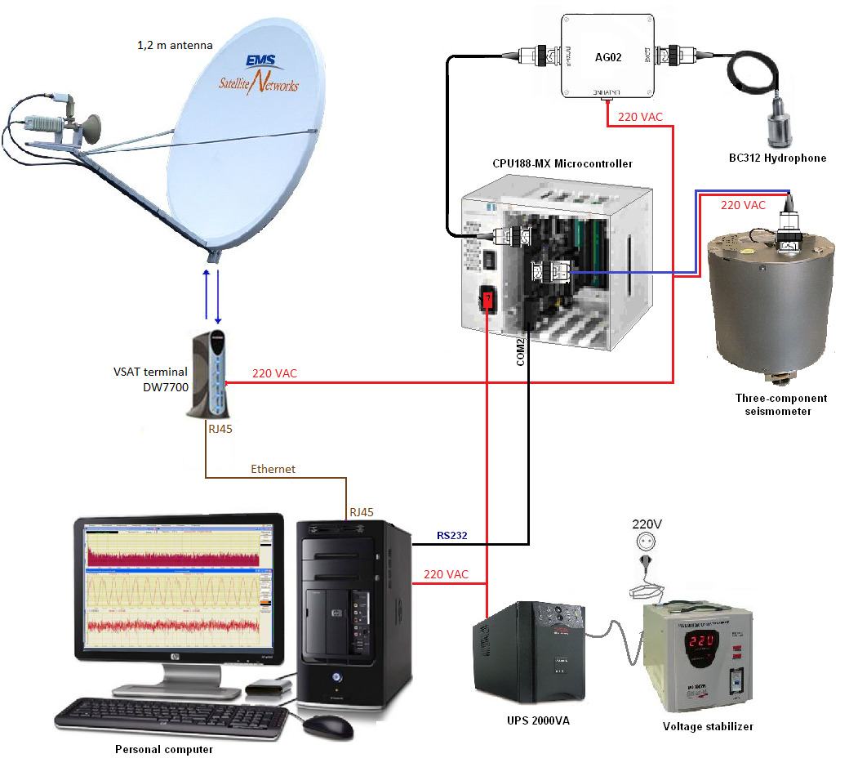
Fig. 3 Structure of RNM ASP station
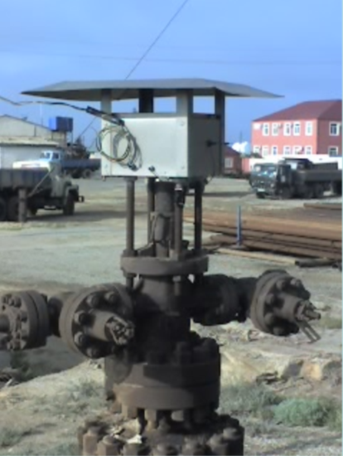
Fig. 4. Appearance of the station after installation
The station includes the following equipment:
- System unit of personal computer;
- Fastwell Micro Pc controller;
- GURALP LTD CMG 5T seismic accelerometer;
- BC 321 hydrophone, made in Zelenograd;
- Reinforcing and normalizing elements;
- Siemense MC35i terminal forming an Internet channel.
The following earthquakes have been registered by Azerbaijan seismic stations during the operation of the station from 01.07.2010 to 15.01.2011.
09.10.2010, town of Masally 00:58:11, M:3.5, d:12 kм
11.10.2010, town of Shirvan, 22:50:23, M:3.9, d:37 kм
17.10.2010, town of Imishli, 07:20:38, M:3.4, d:18 kм
20.11.2010, Caspian Sea, 05:05:48-08:29:29, M:3.5, d: 50 km
25.11.2010, Baku, Sangachal, 09:15:21, M: 3.04, d: 36 km
Given below in Fig. 5a, 5b, 5c, 5d, 5e are the results of ASP monitoring by means of RNM station. The records show that the estimates of noise variance of the seismic acoustic signal received at the output of the hydrophone increase sharply over 5-10 hours before the earthquake, which continues till the end of the earthquake. It should be noted that the distance from an RNM ASP station to remotest earthquakes in the town of Masally is about 200 km.
Fig. 5f demonstrates the record of the estimate of cross-correlation function $R_{xε}\left(μ\right)$ between the useful signal $R_{xε}\left(iΔt\right)$ and the noise$ε\left(iΔt\right)$ related to the earthquakes in Azerbaijan (21.01.2011, 01:58:54), Georgia (23.01.2011, 07:51:23), Tajikistan (24.01.2011, 06:45:29) and on the border with Turkey, Armenia and Iran (3 earthquakes - 25.01.2011, 03:56:12, 04:02:32, 07:40:04). The lead of all the charts over the beginning of the earthquakes is 2-5-7 hours and more.
Fig. 5g gives the expanded record of the estimate of cross-correlation function during the earthquake in Georgia (near Kutaisi) on 23.01.2011. Time 07:51:23 was clearly registered 5-6 hours before the beginning of the earthquake.
On 23.01.2011, Azerbaijan seismic stations registered an earthquake that occurred in Van, East Turkey at 16:00:25, with magnitude 5.6. Fig. 5h gives the record of the estimate of cross-correlation function during the earthquake that lead to human losses and great destructions. The charts show Baku time.
Analysis of algorithms of noise analysis shows that only estimates of characteristics of the noise$ε\left(iΔt\right)$ detect the beginning of origin of anomalous seismic processes reliably and adequately.
Thus, the results of experiments carried out from 01.05.2010 to 20.02.2012 show that it is possible to perform monitoring within a radius of over 200-300 km 10-20 hours before the earthquake by means of RNM ASP. Those results imply that the difference in time between ASP origin and the moment of its critical state that leads to the earthquake changes depending on the location of the earthquake focus. One can assume, based on the obtained results, that, when spreading from the earthquake focus, seismic acoustic waves are reflected due to the resistance of certain upper strata of the earth and change horizontally. One can also assume that it is sufficient intensity of those waves that allows them to travel to long distances [9,19].
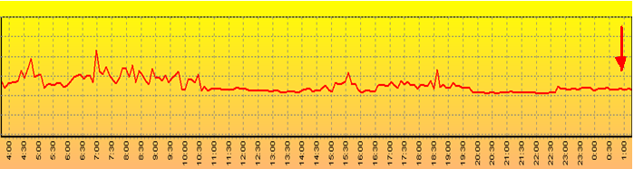
Fig. 5а. 08.10.2010 Masally 00:58:11 M:3.5 d:12 km Noise variance
Start of ASP approximately at 04:30, 08.10.2010, earthquake at 00:58:11, 09.10.2010
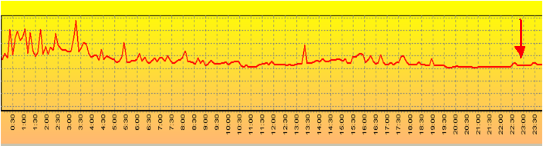
Fig. 5b. 11.10.2010 Shirvan 22:50:23 M:3.9 d:37 km Noise variance
Start of ASP approximately at 00:30, 11.10.2010, earthquake at 22:50:23, 11.10.2010
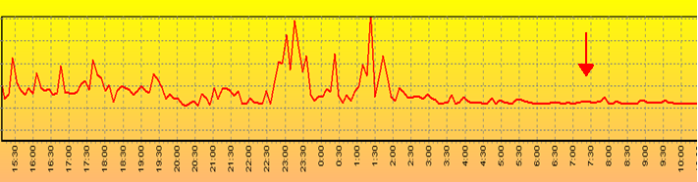
Fig. 5c. 16-17.10.2010 Imishli 07:20:38 M:3.4 d:18 km. Noise variance
Start of ASP approximately at 15:30, 16.10.2010, earthquake at 07:20:38, 17.10.2010
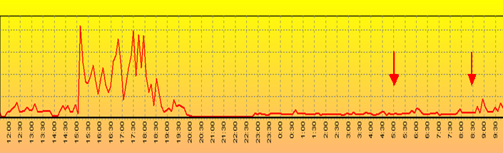
Fig. 5d 19-20.11.2010 At sea 05:05:48--08:29:29 20.11.2010 M:3.5 d: 50 km. Noise variance.
Start of ASP approximately at 12:20, 19.11.2010 г., two earthquakes at 05:05:48, 08:29:29 20.11.2010
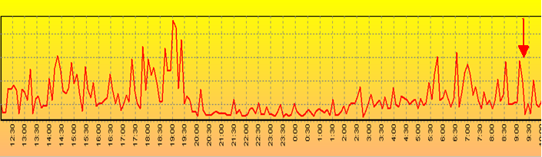
Fig. 5e. 25.11.2010 Baku, Sangachal 09:15:21 M: 3.04 d: 36 km. Noise variance
Start of ASP approximately at 12:10 24.11.2010, earthquake at 09:15:21 25.11.2010
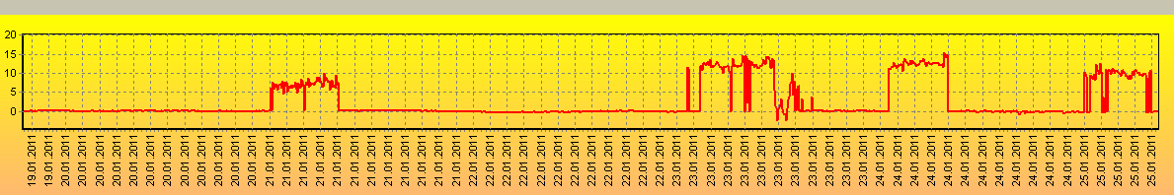
Fig. 5f. In Azerbaijan (21.01.2011, 01:58:54), in Georgia (23.01.2011, 07:51:23.0), in Tajikistan (24.01.2011, 06:45:29.0) and on the border between Turkey and Iran (3 earthquakes 25. 01.2011, 03:56:12.; 04:02:32.; 07:40:04.)
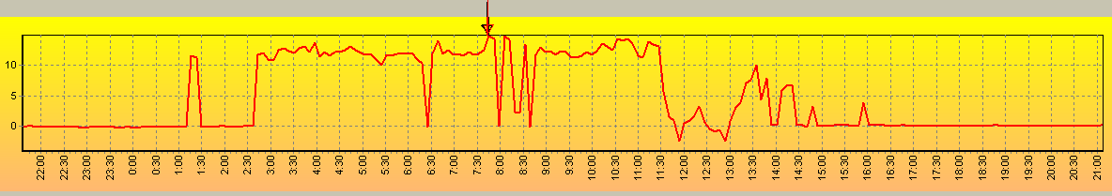
Fig. 5g. 23.01.2011 Georgia, near Kutaisi 07:51:23 M: 4.5 d: 10 km Estimates of cross-correlation function
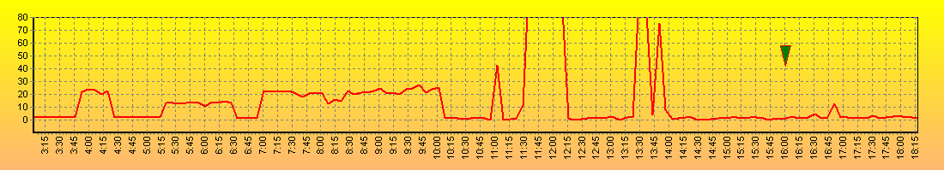
Fig. 5h. 23.10.2011 East Turkey, Van 16:00:25 M: 5.6 Estimates of cross-correlation function
The given experimental results show the expediency of construction of RNM ASP stations. Creation of another three stations is near completion at the present time, one at well No 427 of Shirvan Oil, one at a well of Siazan Oil, and one in Naftalan. Four RNM ASP stations will obviously make it possible to determine the direction of the earthquake focus.
In the future, integration of RNM ASP stations with standard seismic stations will allow one to create intelligent systems, which after a certain training period and a long operational testing period can be used for determining the coordinates and the magnitude of the expected earthquake.
8. Conclusion
The paper considers the possibility of minimization of damage from major earthquakes by means of interrelated solution of problems of control of microchanges in seismic stability of construction objects during frequent weak earthquakes and monitoring of the latent period of ASP origin. Given below are basic results offered for solution of the problem.
- To minimize damage from earthquakes, a system is offered that allows to combine monitoring of the latent period of violation of seismic stability of objects with monitoring of ASP origin. Taking into account the peculiarity of formation of noisy signals in the systems, noise is used as a carrier of diagnostic information, making it possible to solve the problem of monitoring of seismic stability of objects and ASP.
- The offered distributed system allows performing uninterrupted monitoring of microchanges in seismic stability of socially significant construction objects by means of LDNS, assessment of the original state of their seismic stability being determined indirectly. For that end, seismic stability of several fundamental objects is taken as pattern on the server of the system, and the above-mentioned sets and matrices are formed for them. In the process of continuous monitoring of seismic stability of objects, they are compared with patterns. If the difference exceeds a certain threshold level, they are referred to the group that requires monitoring by mobile diagnostic equipment.
Reliability and adequacy of monitoring results are achieved through use of the noise as a carrier of diagnostic information, formation of sets and matrices from robust normalized estimates of correlation functions as well as application of robust, spectral and position-binary indicators.
At the same time, if conventional technologies and systems are used, results of changes in seismic stability of construction objects are registered only when they take an expressed form. The offered technology and system allow one to detect a change in seismic stability at the initial stage, enabling organization of timely precaution measures and prevention of further grave deformations, which will make it possible to reduce the total volume of repair works and amount of finance and sudden failures.
- In case of discovery of simultaneous changes in corresponding estimates of the noise received from a group of closely-spaced objects, the offered distributed noise monitoring system allows detection of initial stages of landslide, forming the alarm to warn the corresponding city services about the possibility of a dangerous and destructive ecological process.
- Results of the experiments at the seismic-acoustic station at Qum Island demonstrated that it is possible to detect the time of ASP origin within a radius of more than 100-250 km several hours before the earthquake by means of estimates of noise variance, noise correlation and cross-correlation functions between noises and useful signals. However, identification of coordinates and magnitude of the earthquake requires creation of another three such stations and their integration with standard seismic stations.
- The results obtained from experimental data allow assuming that the time lead in registration of ASP origin by the seismic-acoustic station over standard seismic stations is due to two factors.
First, seismic-acoustic waves that arise in the beginning of ASP origin do not reach the earth’s surface due to frequency characteristics of certain upper strata, which leads to their horizontal spreading in deep strata as noise. Reaching steel pipes of the well at the depth of over 3-6 km, seismic-acoustic waves transform into acoustic signals and go to the surface at the velocity of sound, where they are detected by the hydrophone. At the same time, low frequency seismic waves from seismic processes are sensed at the surface in a certain amount of time, when the earthquake is already in progress, and are registered by seismic receivers of standard ground equipment much later. Second, application of robust noise technology allows one to analyze noises received from acoustic sensors and register anomalous seismic processes in the beginning of their origin. These two factors make it possible to indicate the time of the beginning of the coming earthquake based on the received seismic-acoustic information much earlier than it is done by stations of the seismic survey service.
- Seismic-acoustic stations of ASP monitoring can also be used for monitoring of the latent period of volcano formation well before the eruption. Their use will also allow one to perform monitoring of testing of minor and major nuclear bombs and other experiments related to manufacture of military equipment on a regional basis. A network of such stations will make it possible to fully control such tests and various military maneuvers.
- Operation of the offered system will allow receiving information on the coming earthquake 10 and more hours before its beginning as well as on technical condition and seismic stability of socially significant construction objects. Timely decision-making on population evacuation from most vulnerable buildings, power, gas, water supply cut, reducing water level in reservoirs of hydroelectric power plants, suspension of chemical and other hazardous production, stopping subway and railroad trains can result in minimization of damage and environmental impact from disastrous earthquakes.
Т.А. Əliyev, А.М. Abbasov, G.А. Quluyev, F.H. Paşayev, Ü.E. Səttarova
DAĞIDICI ZƏLZƏLƏLƏRİN VURDUĞU ZİYANLARIN MİNİMUMLAŞDIRILMASINA İMKAN VERƏN TEXNOLOGİYALAR VƏ SİSTEMLƏR
Annotasiya
Dağıdıcı zəlzələlərin vurduğu zərərlərin minimumlaşdırılmasına imkan verən texnologiyalar və sistemlər təklif olunur. Onlar tikinti obyektlərinin seysmodayanıqlığına nəzarəti və dağıdıcı anomal seysmik proseslərin monitorinqini əlaqəli bir məsələnin həlli kimi həyata keçirməyə imkan verirlər. Sistemdə anomal seysmik proseslərin başlanmasının informasiya əlaməti kimi yerin dərin qatlarından neft quyularının polad boruları vasitəsi ilə alınan seysmoakustik siqnallarla onların küyləri arasında qarşılıqlı korreyasiya funksiyasının qiyməti tapılır. Binaların seysmodayanıqlığının gizli dövrü isə Noise monitorinq texnologiyası əsasında təyin olunur. Alınan bütün informasiyalar radiokanal vasitəsi ilə serverə verilir və orada anomal seysmik proseslərin başlanması, eləcə də seysmodayanıqlığı dəyişmiş obyektlərin müəyyənləşdirilməsi həyata keçirilir.

References
- Коллакот Р. Диагностика повреждений. М: Мир,1989, с. 516.
- Aliev T. Digital noise monitoring of defect origin, London, Springer-Verlag, 2007. p. 223.
- Aliev T.A. Robust Technology with Analysis of Interference in Signal Processing, New York, Kluwer Academic/Plenum Publishers, 2003. P.199.
- T.A. Aliev, G.A. Guluyev, F.H. Pashayev, A.B. Sadygov. Noise monitoring technology for objects in transition to the emergency state. Mechanical Systems and Signal Processing, Volume 27, February 2012, pp. 755–762.
- Aliev, T.A., Alizada T.A., Abbasov, A.A. Method for monitoring the beginning of anomalous seismic process. International Application No PCT/AZ2005/000006, Pub.No WO2006/130933, International Filling Date – December 19, 2005.
- Aliev, T.A., Abbasov, A.A., Aliev, E.R., Guluev, G.A., Method for monitoring and forecasting earthquakes. International Application No PCT/AZ2006/00000, Pub.No WO2007/143799, International Filling Date – June 16, 2006.
- Aliev, T.A., Abbasov, A.M., Aliev, E.R., Guluev, G.A., Method for monitoring and forecasting earthquakes. Eurapian Asian patent No 011003. International Application No PCT/AZ2006/00000, Pub.No WO2007/143799, International Filling Date – June 16, 2006.
- T.A. Aliev, A.M. Abbasov, E.R. Aliev and G.A. Guliev. Digital technology and systems for generating and analyzing information from deep strata of the Earth for the purpose of interference monitoring of the technical state of major structures. Automatic Control and Computer Sciences, Allerton Press, Inc., New York (2007), No.2, pp.59-67.
- T.A. Aliev, A.M. Alizada, G.D.Yetirmishli, G.A. Guluyev, F.G. Pashayev, A.G. Rzayev. Intelligent seismoacoustic system for monitoring the beginning of anomalous seismic process. Seismic Instruments, Vol. 47, #1, 2011, pp. 27-41.
- Aliev, T.A., Abbasov, A.M. Digital Technology and the system of interference monitoring of the technical state of consractive objects, and the system of the signaling of abnormal seismic processes // Automatic Control and Computer Sciences, Allerton Press, Inc., 2005.№ 6, p.3-10
- T.A. Aliev, A.M. Abbasov. Digital technology and the system of
interference monitoring of the technical state of constructive
objects, and the system of the signalling of abnormal seismic
processes. Automatic Control and Computer Sciences, Allerton Press,
Inc., New York (2005), Vol. 39, No.6. pp. 1–7.
- T.A. Aliev, A.M. Abbasov, G.A. Guluyev, A.H. Rzayev, F.H. Pashayev.
Position-binary and spectral indicators of microchanges in the technical states of control objects. Automatic Control and Computer Sciences, Allerton Press, Inc., New York, No.3, 2009.pp.156-165
- T.A. Aliev, G.A. Guluyev, F.H. Pashayev, A.B. Sadygov. Noise monitoring technology for objects in transition to the emergency state. Mechanical Systems and Signal Processing, Volume 27, February 2012, pp. 755–762.
- Osman E. Ozbulut, Stefan Hurlebaus Re-centering variable friction device for vibration control of structures subjected to near-field earthquakes, Mechanical Systems and Signal Processing Volume 25, Issue 8, November 2011, Pages 2849–2862
- Ying Lei , Yongqiang Jiang, Zhiqian Xu Structural damage detection with limited input and output measurement signals, Mechanical Systems and Signal Processing Volume 28, April 2012, Pages 229–243
- Byungyoung Moon, Choon-Tae Lee, Beom-Soo Kang, Byeong Soo Kim, Statistical random response analysis and reliability design of structure system with non-linearity, Mechanical Systems and Signal Processing, Volume 19, Issue 5, September 2005, Pages 1135–1151
- T. A. Aliev, N. F.Musaeva, Sattarova U.E, Robust technologies for calculating normalized correlation functions. Cybernetics and Systems Analysis, New-York,Vol. 46, No. 1, pp. 153-166, 2010
- T.A. Aliev N.F.Musaeva Technology of calculating robust normalized correlation matrices, Cybernetics and System Analysis, New-York,Vol. 47, No. 1, pp. 152-165, 2011
- Manga, M. and C.-Y. Wang, 2007, Earthquake hydrology, Treatise of Geophysics, 293-320

